Financial Fraud Detection: Anomaly Detection in Credit Card Transactions

Business Introduction:

Welcome to SecureGuard Financial Solutions, a leading provider of innovative fraud detection analysis
for the financial industry. At SecureGuard, we specialize in developing cutting-edge solutions to
safeguard our clients' assets and protect against fraudulent activities in real-time.

Our mission at SecureGuard is to provide comprehensive fraud detection services that empower
financial institutions to maintain the trust and confidence of their customers while minimizing financial
losses due to fraudulent transactions.

With the increasing prevalence of online transactions and digital payments, the risk of fraudulent
activity has become a significant concern for financial institutions worldwide. From unauthorized
credit card transactions to identity theft, the threat of fraud poses a substantial risk to both financial
institutions and their customers.

That's where SecureGuard comes in. By analyzing patterns and anomalies in transaction data, our
system can swiftly flag potentially fraudulent transactions, enabling financial institutions to take
immediate action to mitigate the risk.

Problem Statement:

Design a fraud detection system to identify fraudulent credit card transactions in real-time. The system
should detect suspicious activities such as unauthorized transactions, unusual spending patterns, and
fraudulent card usage to prevent financial losses for both cardholders and financial institutions.

Excel Tasks:

- Data Exploration:

• Statistical summary on amt and city_pop.

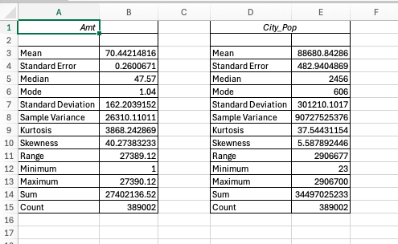

• A Histogram on ‘amt’ column.

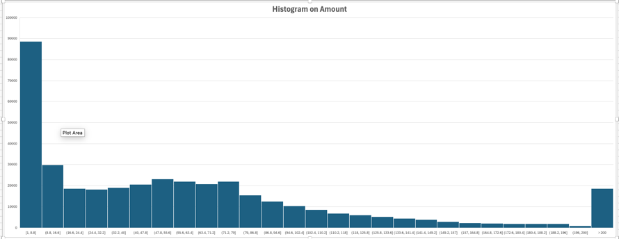

• A report showing number of Frauds by gender and category

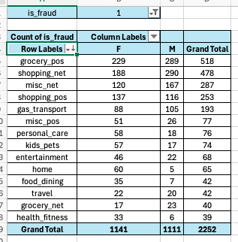

• Top 3 states by the highest number of transactions

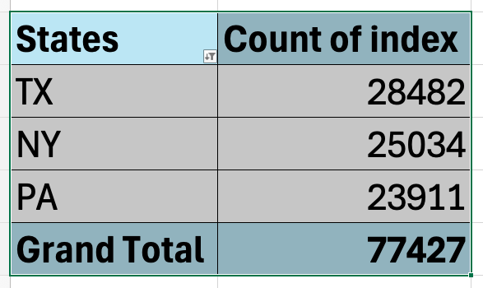

- Data Analysis in Excel:

• Count fraudulent transactions per category.

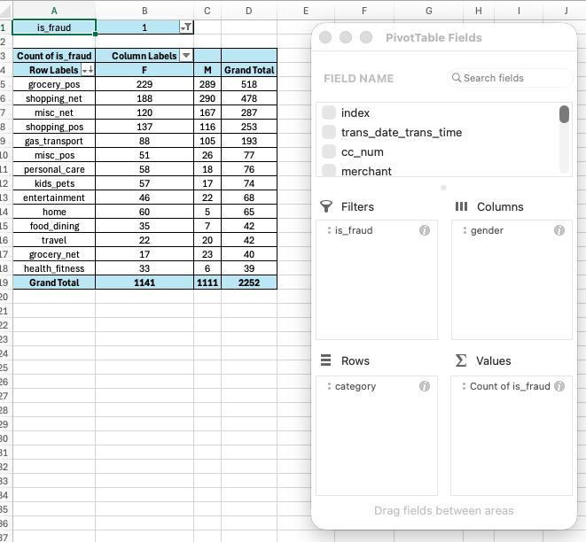

• Compared average transaction amount across job roles?

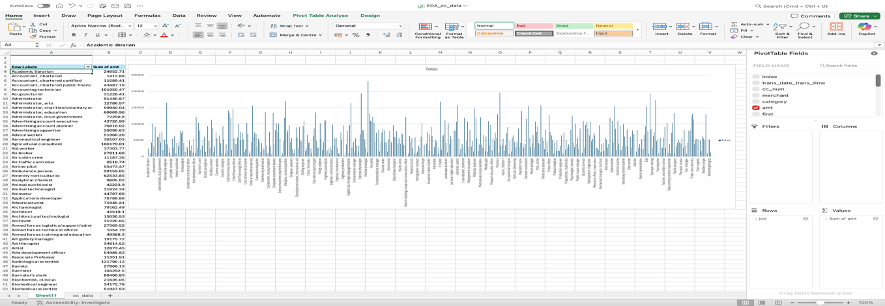

SQL Tasks:

- Data Loading:

• Created a schema named finance, set finance as the default schema, and created tables
with cc_data.csv and location_data.csv

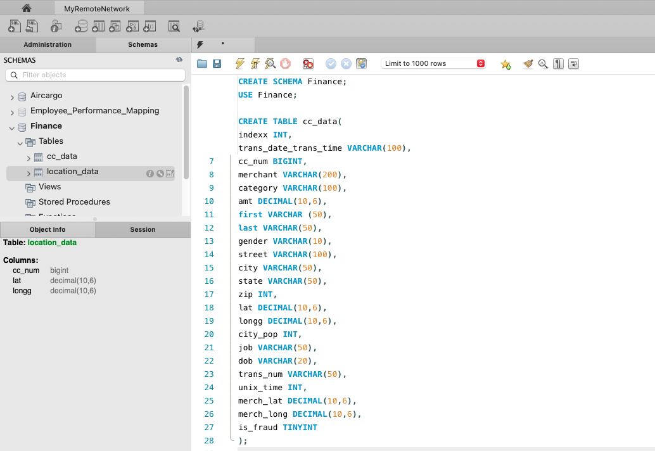

- Data Exploration with SQL:

• Total number of transactions in the cc_data table

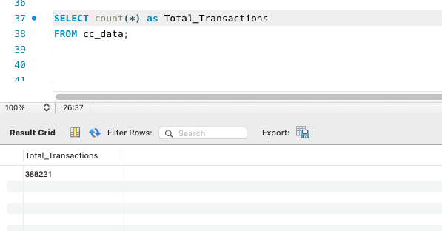

• Top 10 most frequent merchants in ‘cc_data’ table.

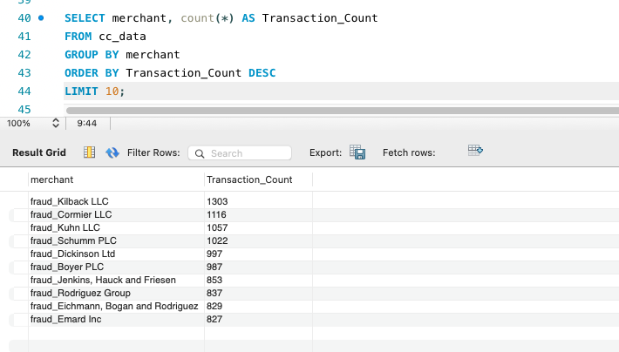

• Average transaction amount by category in ‘cc_data’ table.

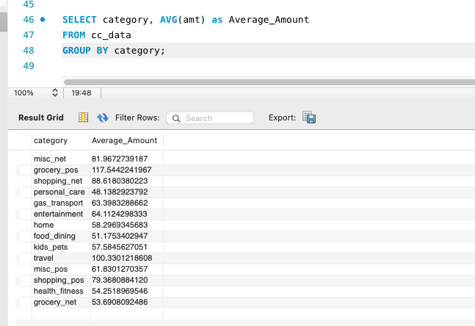

• Number & Percentage of fraudulent transactions.

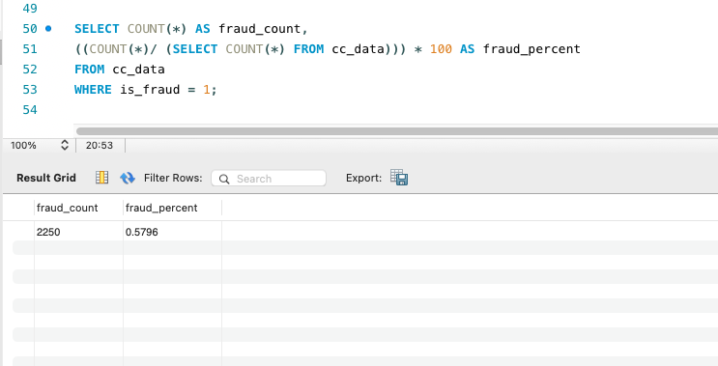

• Joined the cc_data and location_data tables to retrieve co-ordinates.

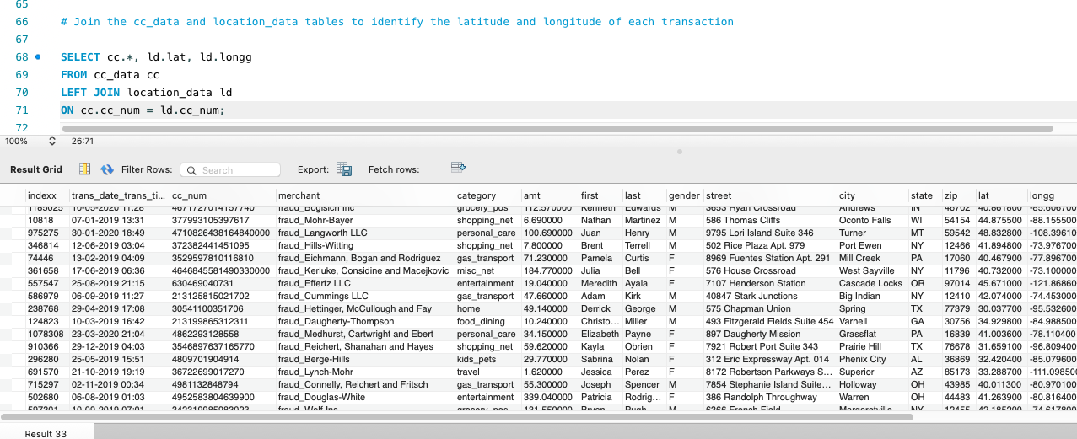

• Identified the city with the highest population in ‘location_data’ table.

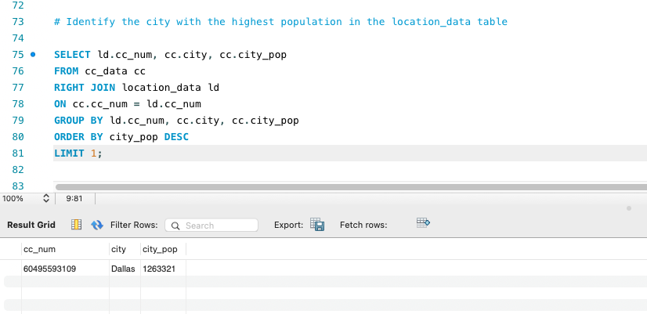

• Found the earliest and latest transaction dates in the cc_data table

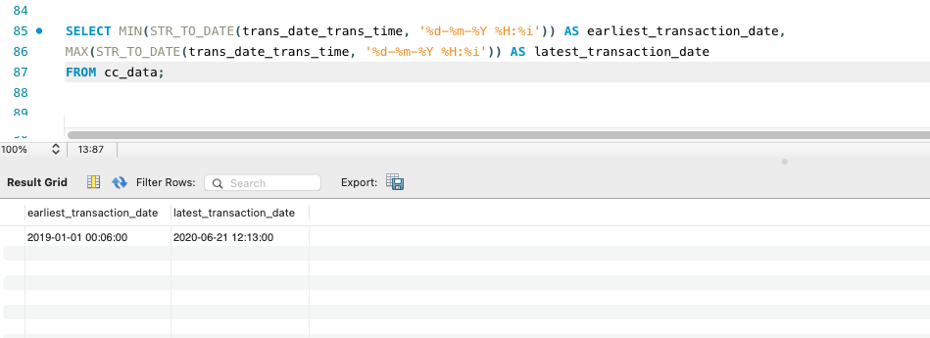

- Using Data Aggregation with SQL:

• Total amount spent across all transactions in the cc_data table?

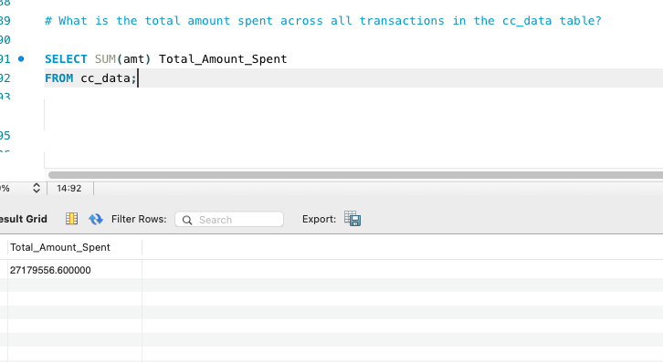

• Transactions count by category in the cc_data table.

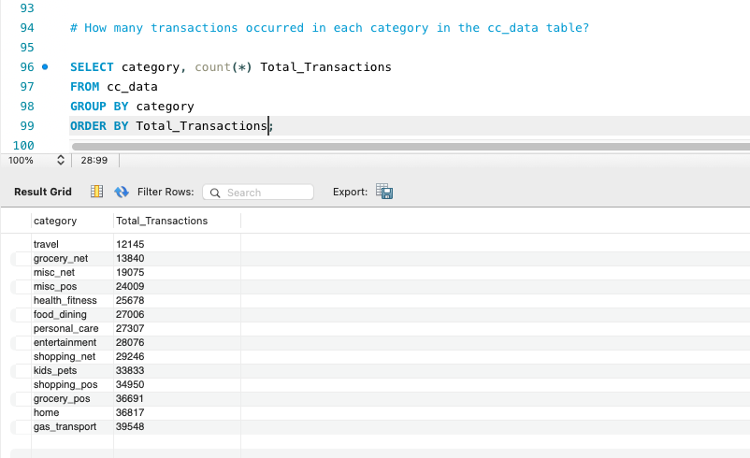

• Average transaction amount by gender in the cc_data table.

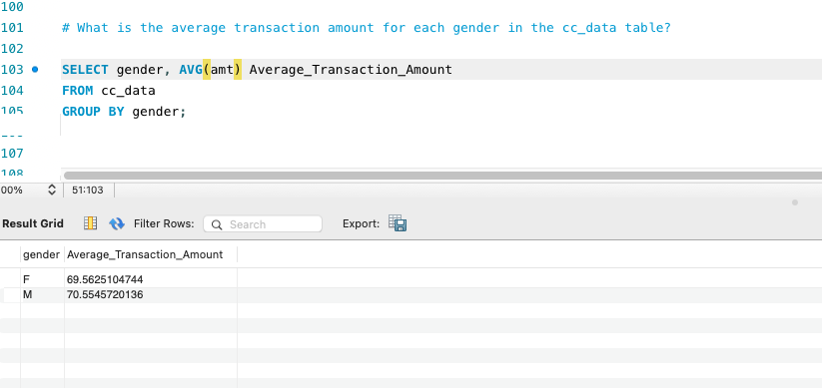

• Day of the week has the highest average spending in the cc_data
table

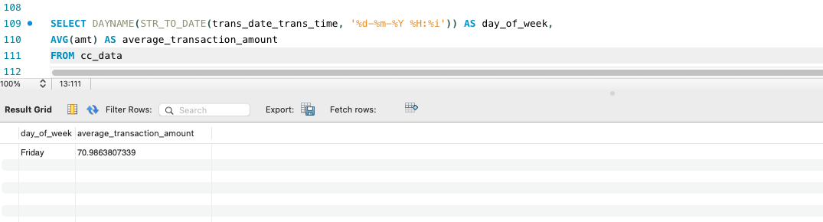

Python Tasks (including EDA):

- Exploratory Data Analysis (EDA) with Python:

The following questions were answered using Python and Pandas:

• Dataset Shape

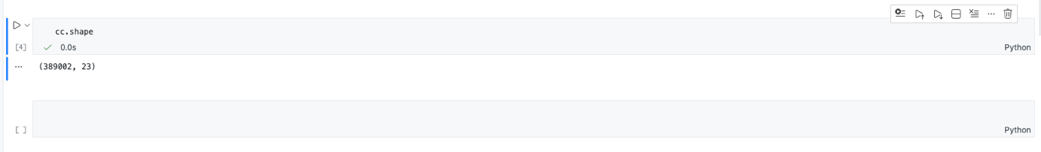

• Unique categorical values

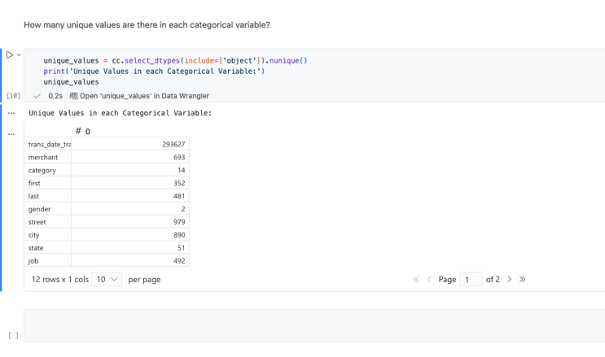

• Distribution of numerical features.

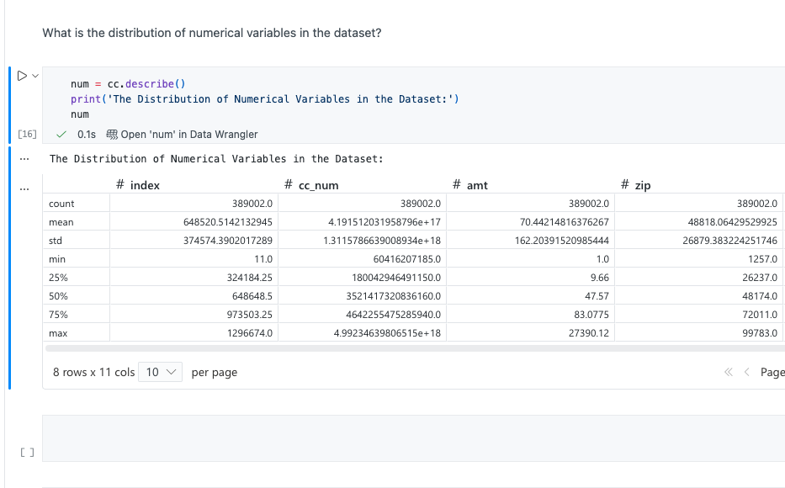

• Missing values analysis

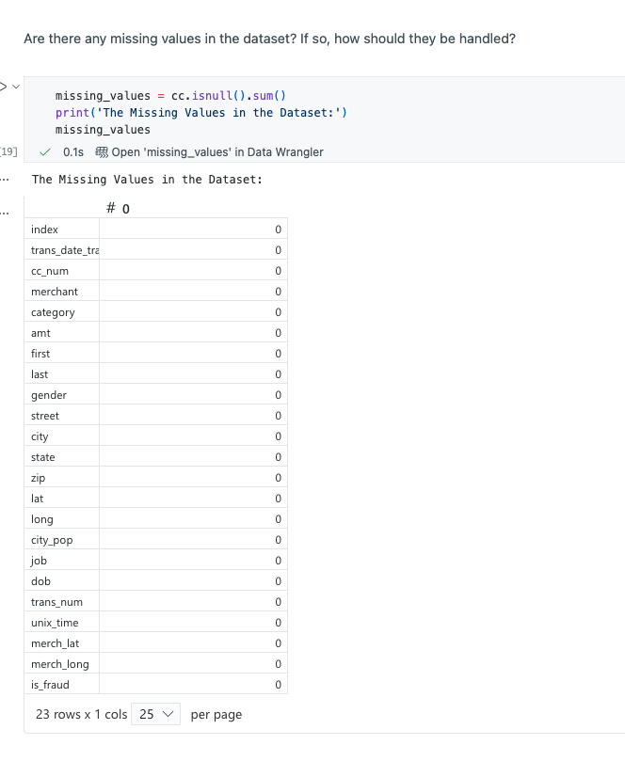

• Summary statistics

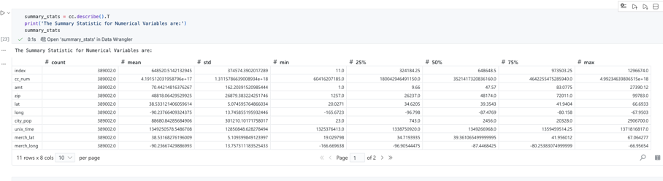

• Correlation Analysis

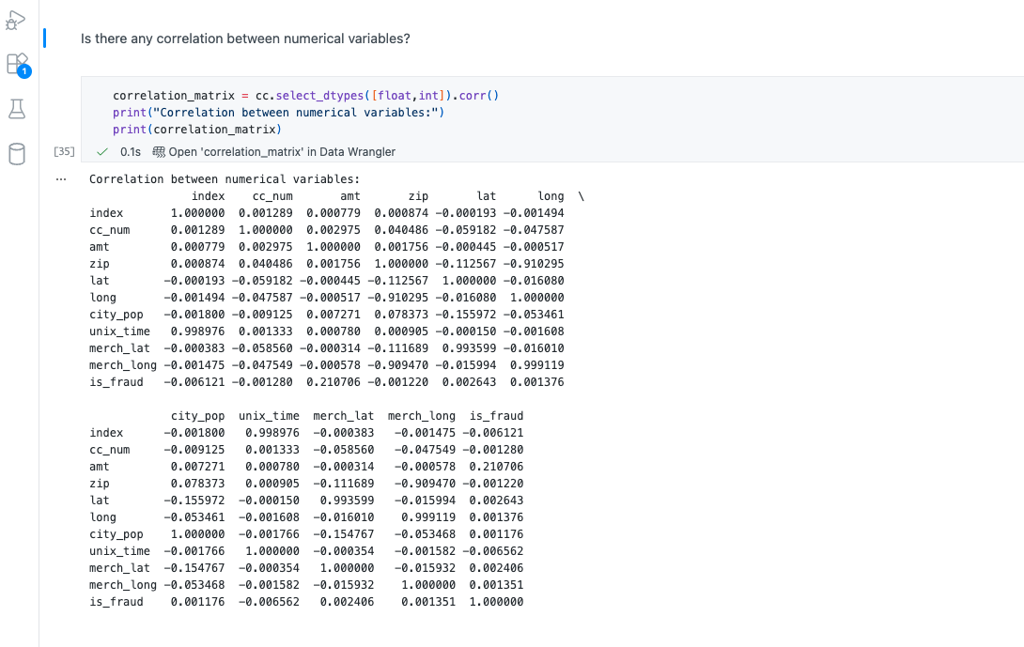

• Amount distribution across fraud Vs Non fraud

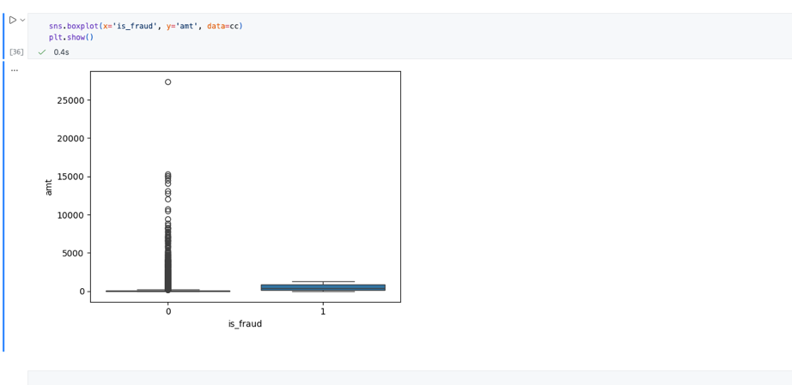

• Outlier detection (city_pop ,amt)

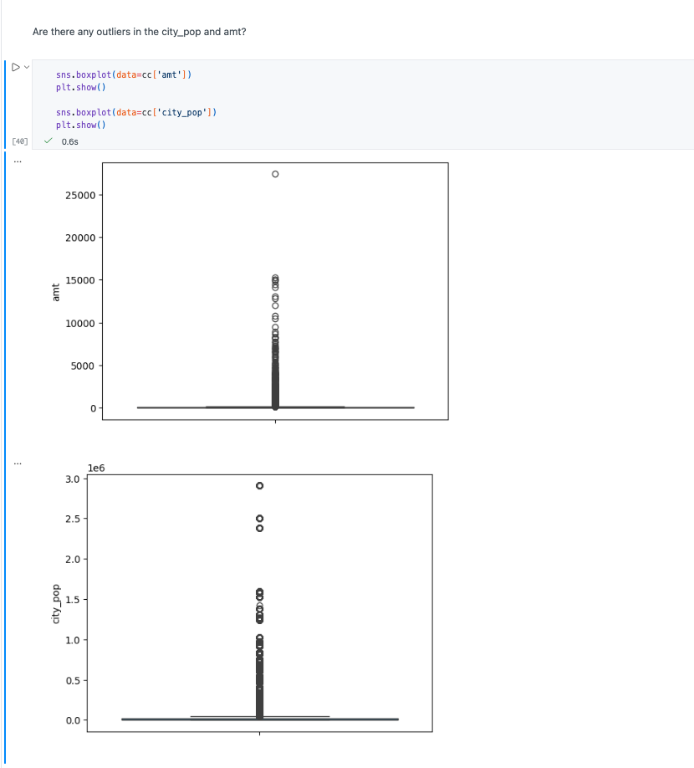

• Time Based Trends

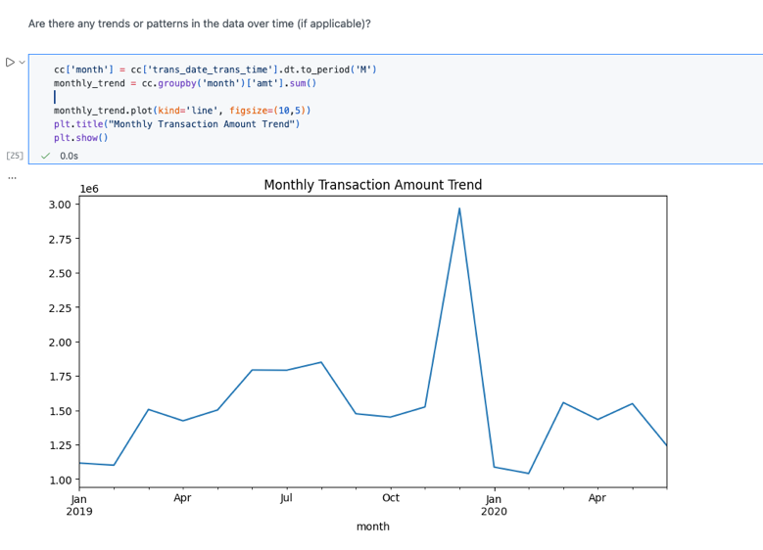

• Target variable distribution

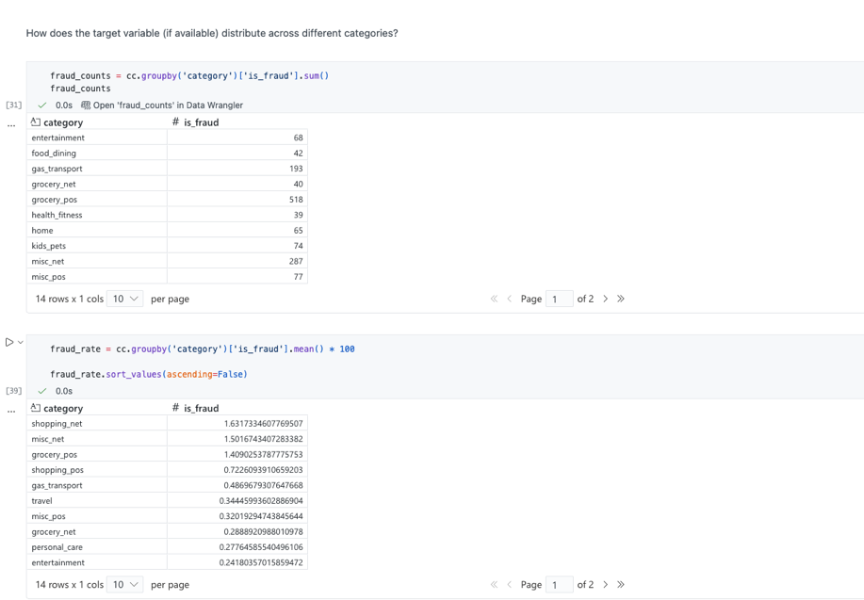

• Data Quality Checks

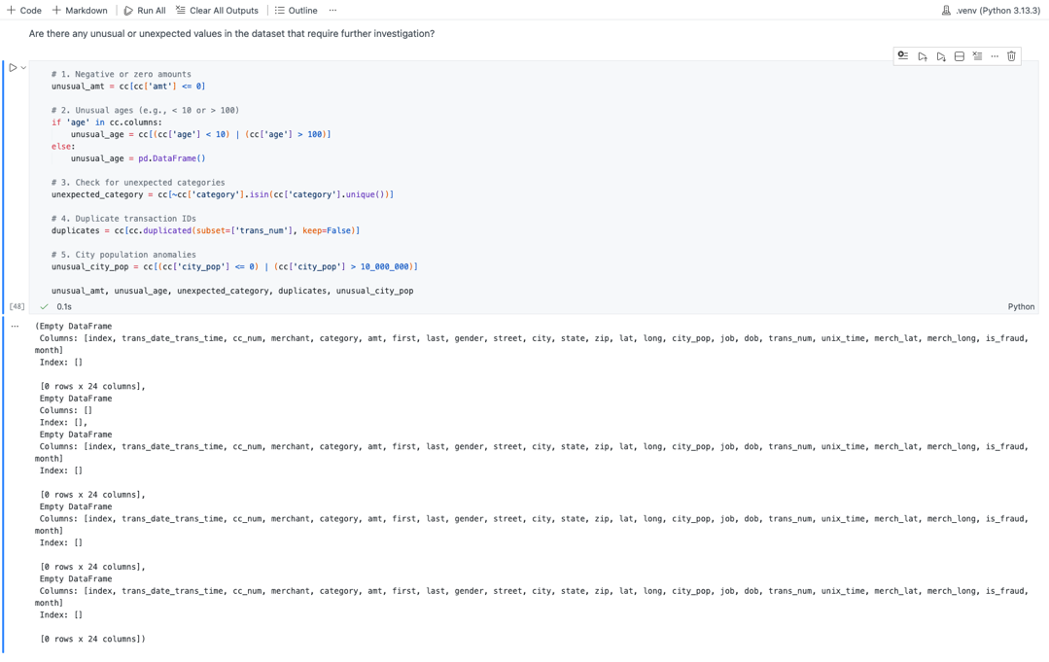

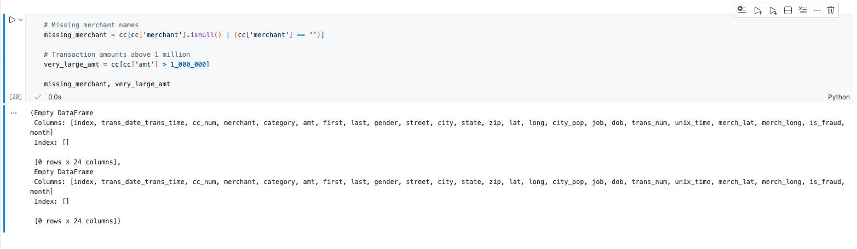

• Segment-wise variation analysis

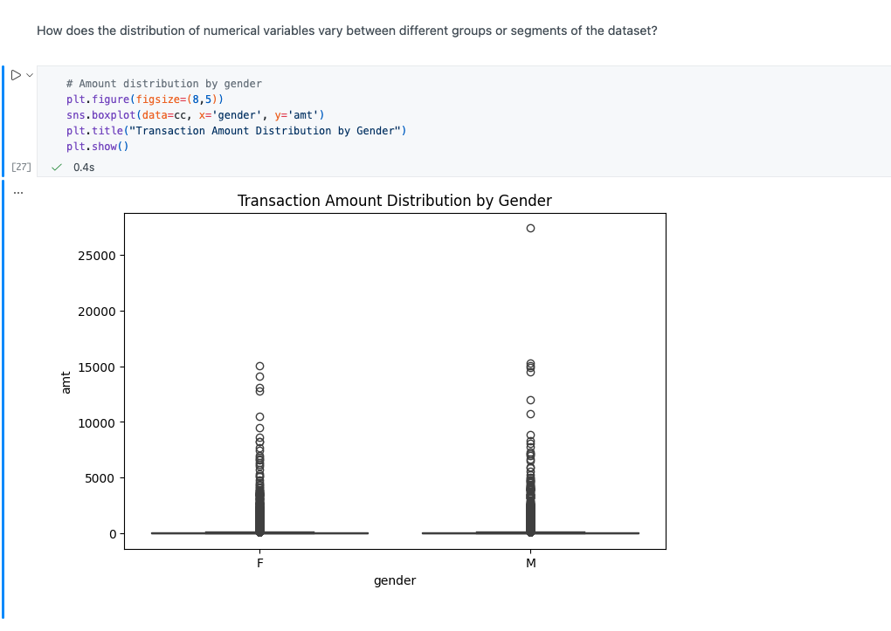
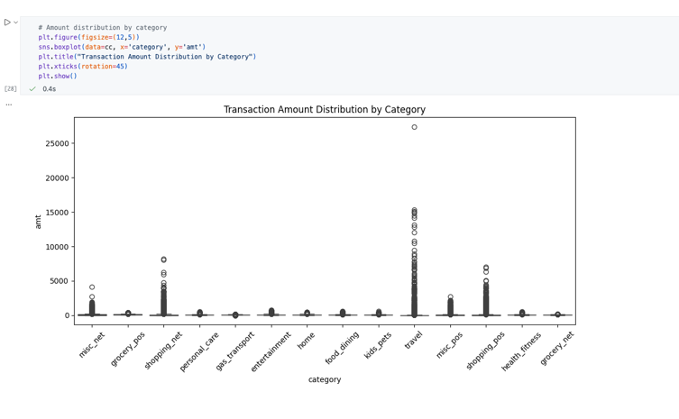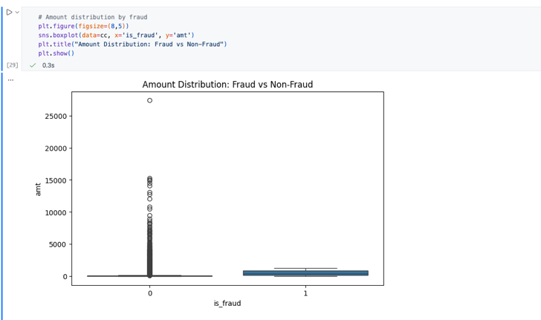

• Final analytical report

# Exploratory Data Analysis (EDA) – Summary of Insights

After conducting a thorough Exploratory Data Analysis (EDA) on the dataset, several key insights and observations have been identified:

1. **Dataset Dimensions**:

- The dataset contains **389,002 rows** and **23 columns**, providing a robust sample size for fraud pattern identification.

2. **Unique Categorical Values**:

- Most categorical columns have extremely high cardinality, with several containing up to **389,002 unique values**, indicating transaction‑level uniqueness.

3. **Numerical Distribution**:

- Upon analyzing the distribution of numerical variables, we observed that most financial variables such as amt and city_pop exhibit a right-skewed distribution with notable outliers, whereas lat and long show a geographic spread rather than a normal distribution. Variables like cc_num and zip are identifiers and do not carry meaningful statistical distribution. The target variable is_fraud is extremely imbalanced, with fraud cases representing less than 1% of total transactions.

4. **Missing Values**:

- No missing values detected → dataset is clean.

5. **Summary Statistics**:

- Overall, the numerical variables show significant skewness and variability. Transaction amounts and city populations are both right-skewed with notable outliers. Geography-based variables (lat, long) follow non-normal distributions, while cc_num and zip serve as identifiers rather than meaningful numeric measures. Most importantly, the target variable is_fraud is extremely imbalanced, with less than 1% fraudulent transactions, indicating the need for careful handling during model development.

6. **Correlation Analysis**:

- The correlation analysis of the numerical variables shows that there is generally very weak or no linear relationship among most features in the dataset. The transaction amount (amt) has the strongest positive correlation with the target variable is_fraud, but the value is only 0.22, indicating a weak correlation. This suggests that fraudulent transactions tend to involve slightly higher amounts, but the relationship is not strong enough to predict fraud by transaction amount alone. Other variables such as city population (city_pop), latitude (lat), longitude (long), and ZIP code (zip) show correlations close to zero, meaning they have no meaningful linear relationship with fraud. Similarly, there is no significant correlation among the numerical predictors themselves, indicating that the dataset does not suffer from multicollinearity. Overall, the correlation matrix suggests that fraud detection in this dataset cannot rely on simple linear relationships and will require more complex, non-linear modeling techniques.

7. **Amount Distribution Across Fraud**:

- The boxplot comparing transaction amounts (amt) across the two is_fraud categories reveals a clear difference in their distributions. Fraudulent transactions (where is_fraud = 1) tend to have significantly higher transaction amounts compared to non-fraudulent transactions. The median amount for fraud cases is substantially higher, and the overall spread of values is much wider. In contrast, non-fraudulent transactions (is_fraud = 0) are mostly concentrated around lower amounts with a large number of very small transactions. Although there are some high-value outliers in both groups, fraudulent transactions consistently show a higher central tendency and variability. This indicates that fraud is more likely to occur in transactions involving larger amounts, aligning with the moderate positive correlation observed between amt and is_fraud.

8. **Outliers**:

- The boxplots for the numerical variables amt (transaction amount) and city_pop (city population) indicate the presence of significant outliers in both features. For amt, most transactions occur at relatively low values, but several transactions extend far beyond the typical range, reaching amounts above $7,000. These extreme high-value points represent clear outliers. Similarly, city_pop displays a highly skewed distribution, with most cities having small to medium populations but a few entries representing very large metropolitan areas with populations exceeding 2 million. These observations confirm that both variables contain substantial outliers, which are expected given the real-world variability in transaction amounts and city sizes. While these outliers may influence statistical models, they should not be removed blindly, as they may carry meaningful information—particularly in fraud detection where extreme values can be important indicators.

9. **Trends Over Time**:

- The monthly transaction trend shows noticeable fluctuations in overall transaction volumes throughout the timeline. From early 2019 to mid-2019, transaction amounts gradually increased, suggesting a steady rise in customer activity. A significant spike is observed around December 2019, where the total transaction amount peaks sharply, indicating a seasonal surge—likely associated with holiday spending. Immediately after this spike, the transaction volume drops back to normal levels in early 2020. Aside from the seasonal peak, the remaining months show moderate variation but no consistent upward or downward trend. Overall, the pattern suggests that transaction behavior is influenced more by seasonal or event-driven factors rather than long-term structural trends.

10. **Target Variable Distribution**:

- Fraud is not evenly distributed across spending categories. Categories such as shopping_net, misc_net, grocery_pos, and shopping_pos show the highest fraud rates, making them the most vulnerable segments. Although categories like grocery_pos and gas_transport also show high fraud counts, this is largely due to their high transaction volumes. In contrast, categories such as entertainment, personal_care, and kids_pets exhibit very low fraud rates. Overall, online shopping and high-activity point-of-sale categories carry the greatest fraud risk.

11. **Unusual Values & Data Errors**:

No anomalies such as:
- Negative amounts
- Invalid ages
- Missing merchants
- Implausible large transactions
Dataset is consistent and production-ready.

12. **Segment Variation**:
- The distribution of transaction amounts varies notably across different segments of the dataset. When comparing fraud and non-fraud transactions, fraudulent transactions tend to involve significantly higher amounts, with visibly larger medians and a wider spread, indicating that higher-value payments are more likely to be associated with fraud. Transaction amounts also differ across spending categories: certain categories such as travel, shopping_net, and grocery_pos show much larger transaction values and more pronounced outliers, whereas categories like entertainment, personal_care, and food_dining exhibit relatively low and consistent amounts. This reflects the natural difference in spending behavior across merchant types. Finally, when comparing transaction amounts by gender, both male and female customers show very similar distribution patterns, with no meaningful difference in median values or spread. Overall, transaction amount differences are primarily driven by fraud status and category, while gender does not appear to influence spending amounts.

In conclusion, the EDA process has provided valuable insights into the dataset, facilitating a better understanding of its characteristics and informing subsequent steps in the development of a fraud detection system. By leveraging Python for EDA, we were able to efficiently explore, analyze, and visualize the data, enabling informed decision-making and the development of robust fraud detection solutions.

Based on the insights obtained from the Exploratory Data Analysis, several actionable recommendations can help strengthen fraud prevention efforts and improve decision-making:

1. **Prioritize Monitoring of High-Risk Categories**
Categories such as shopping_net, misc_net, grocery_pos, and shopping_pos show disproportionately high fraud rates. These segments should receive enhanced rule-based alerts, stricter authentication checks, and closer real-time monitoring.

2. **Implement Threshold-Based Alerts for High-Value Transactions**
Fraudulent transactions tend to involve significantly higher amounts. Establishing dynamic or category-specific transaction thresholds can help flag unusual spending behavior more effectively.

3. **Utilize Advanced Machine Learning Models**
With fraud representing less than 1% of the data and weak linear correlations among features, traditional models alone will not perform well. Use non-linear models (e.g., Random Forest, XGBoost, Neural Networks) with techniques like class weighting or SMOTE to handle extreme class imbalance.

4. **Strengthen Online Transaction Security Controls**
Since online shopping categories show the highest fraud risk, businesses should reinforce digital security—such as multi-factor authentication, device fingerprinting, and behavioral analytics—to reduce fraudulent attempts.

5. **Enhance Customer Segmentation for Better Risk Profiling**
Fraud behavior varies across categories but not by customer gender. Focusing on transaction patterns, geography, category behavior, and amount-based segmentation will allow for more targeted fraud prevention strategies.

6. **Incorporate Seasonal Fraud Patterns into Monitoring Rules**
The spike in December suggests seasonal fraud risk during holidays. Temporary tightening of fraud detection rules during peak seasons can significantly reduce losses.

7. **Maintain Robust Data Quality Checks**
Although no inconsistencies were found in the current dataset, ongoing monitoring for missing values, duplicate transactions, or unrealistic entries is essential to prevent incorrect decision-making in live systems.

8. **Provide Customer Education on Safe Spending Practices**
Since fraud often involves higher-value and online transactions, businesses should educate customers about recognizing phishing attempts, securing payment information, and reporting suspicious activity quickly.

By implementing these recommendations, organizations can significantly enhance their fraud detection capabilities, reduce financial losses, and improve the overall security of their transaction ecosystem.

Tableau Tasks:

- Interactive Dashboard Design in Tableau:

• Box‑whisker plot: gender vs category spend

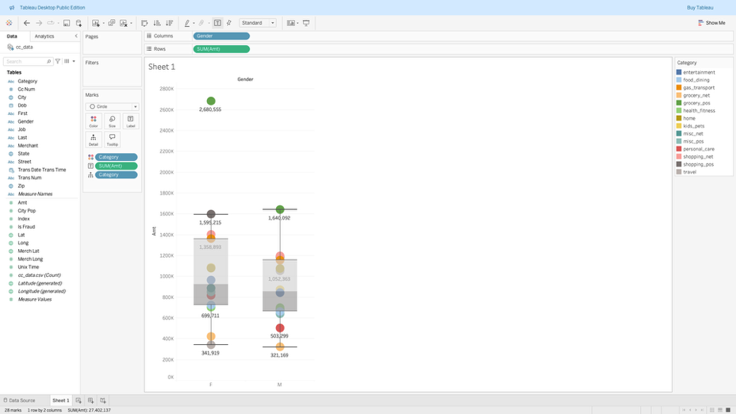

• Geographic mapping using latitude/longitude

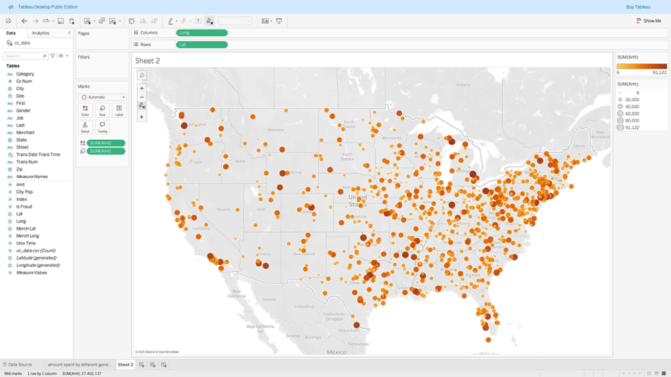

• Fraud heatmap on geographic plots

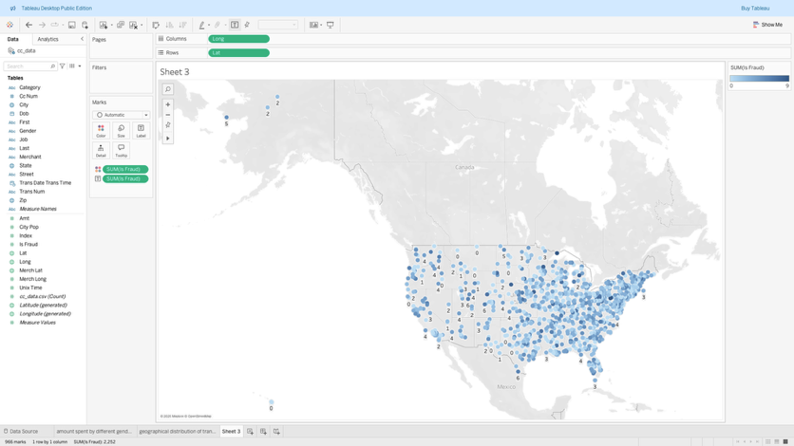

• Monthly transaction time‑series

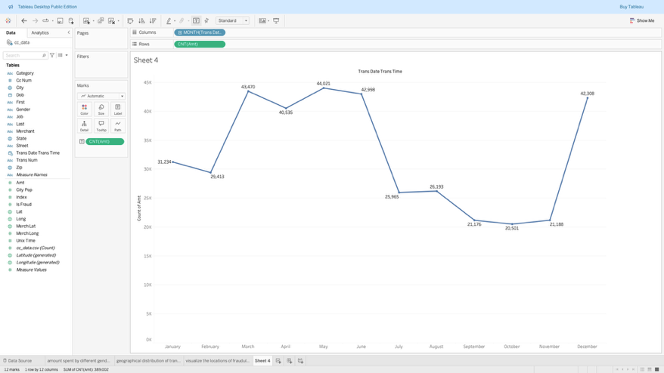

• Calculated Field for Inflation-Adjusted Transaction Amounts

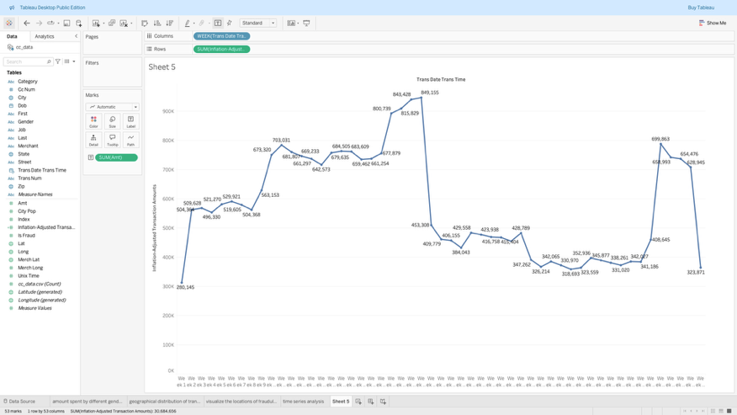

• Build final interactive dashboard

